THE ORGAN IN BINGLEY ALL SAINTS

The present organ in Bingley All Saints has an interesting history. It started out its life as an instrument built by William Hill of London, and was supplied to Sion Baptist Church in Bradford, being intsalled there in 1883.
It had 4 speaking stops on the pedal, 9 speaking stops on the Great. 10 speaking stops on the Swell and 6 speaking stops on the choir. Sometime later (date unknown) it was rebuilt by the Bramley Organ building firm of Binns.

In 1952 major repairs to the fabric of Binglery All Saints were carried out, following the building of the vestries. Due to the fact that the dilapidated stonework of the Southeast window needed attention the PCC decided to have the organ rebuilt. Dr. Francis Jackson was appointed as acting consultant, and on his advice, the Driver and Haigh instrument (which had dilapidated pipe work) was deemed unfit be converted into a modern instrument without undue effort and expense.

The Sion Jubilee Chapel in Bradford had recently closed, and the three manual Hill organ was purchased at a cost of £525.

In 1960 the organ builders J W Walker & Sons built the instrument in the Ryshworth Chapel, with a metal and wood grille designed by Mr George Pace of York.
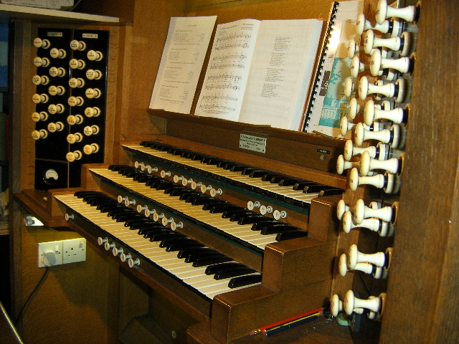
The present organ console
There was insufficient room in the Ryshworth Chapel for the positif section of the organ, (which had originally been the choir organ when it was purchased from Sion Baptist Church) so this was housed in a free standing “Ruckpositiv” case.
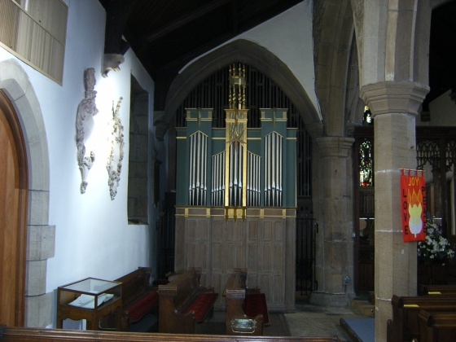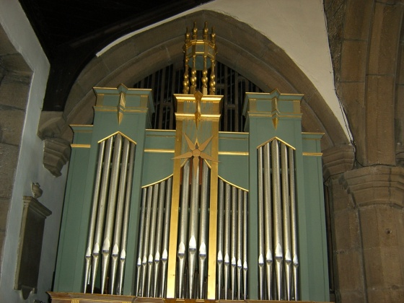
Freestanding “Ruckpositiv” Close up showing rotating star
linked to the zimbalstern
From 1960 onwards various additions and alterations were made to the instrument. The zimbalstern was added.

Great Organ
Addition of a Twelfth in 1960 Addition of a Dulciana in 1970 Trumpet – new unit chest for electro pneumatic action

Pedal Organ Addition of a Chimney Flute in 1960 Addition of a three rank Mixture [15 – 19 – 22] in 1960 Addition of new bass pipes for the Posaune [remainder derived from the Great trumpet]

Positiv

Addition of a Crumhorn in 1960

Further information (including the current full specification) can be obtained from the National Pipe Organ Register. Enter search code A00521.

